13th November 2017

So I have decided to switch to the STFT. It is faster and (practically) more flexible than the CWT (at least I can do the STFT on my own machine), despite CWT having O(n) complexity and the STFT having O(nlogn) complexity.

One of the problems I was having with the STFT before was that it didn’t seem to be fine grain enough for my use. However, after reading up yesterday that increasing the FFT size can increasing the frequency resolution, and increasing the overlap between points can increase the time resolution, I set about testing this to see how good a spectrogram I could get without it taking years to compute. So I generated spectrograms for the following sizes and overlaps:

Window Size | Overlap
1024 | 512
1024 | 768
1024 | 896
2048 | 1024
2048 | 1536
2048 | 1792
4096 | 2048
4096 | 3072
4096 | 3584
8192 | 4096
8192 | 6144
8192 | 7168
8192 | 7680

On the last of these, computation time was slightly increased but in now way would it be considered an issue, as long as Python can deal with the memory consumption.
Zooming in on the ‘For The Love Of God’ spectrogram, I get this:

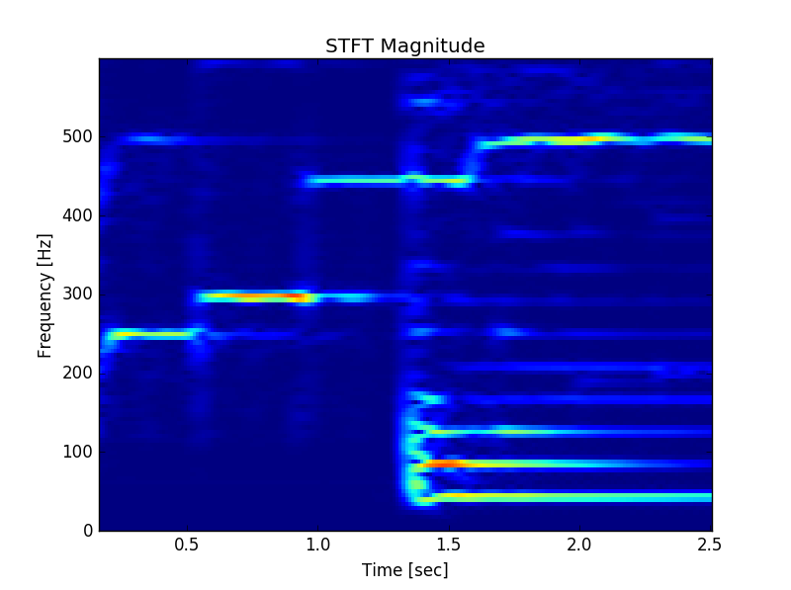

This is more than enough granularity for what I need so now I can get on with the thresholding!

Some things I notice:

Under about 200Hz, no guitar is present
What I’m presuming to be the drums/bass give large vertical bars. This could be exploited in a filter.

A quick note about frequencies:
200Hz is G#3 which is 16th fret on the low E string, 11th fret on the A string, and 6th fret on the D string.
150Hz is D3, which is the 10th fret on the low E string, 5th fret on the A string, and an open D string.

Generating spectrograms for my other files gives me a level of confidence that using this method might actually bring about something cool. Now I’m gonna revise compilers for a little bit.

As of 14:25, I have my closest attempt yet. I have got a sound file which sounds a little weird, but it is clearly the melody. I just need to tweak it very slightly such that I can get the tails of the guitar notes in. Then I need to check it works generally. But this is progress!!!!

Having freed up the algorithm to allow parameters of my own choosing, I can confirm that this seems to be working fairly consistently. The godsticks are the worst performers, but I am really happy with the vai one, the cliffs of dover one and the wilson one! I just need to do a little tweaking (I could do with a low pass filter to filter out some of the remaining high-pitched sounds, but that shouldn’t be too complicated. I could even try and do some stitching if I wanted to, to try and bring the note segments together, but it might not be necessary with a bit of tweaking).

Now I’m gonna move back to the scientific paper for a bit I think, and move back to this fiddly stuff tomorrow!

All I have left on the ICA in the time-frequency domain section is the qualitative analysis section. That shouldn’t take too long, but I’d rather do it tomorrow.

